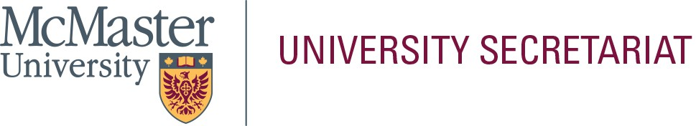

In the space below, please provide a statement (approximately 300-words) that will be helpful to the electorate in their selection. This page will be posted to the University Secretariat website exactly as submitted by the nominee; do not submit personal information on this page (i.e., address, telephone number, e-mail address, photograph, etc.). Please limit your statement to this page only.

**Name of Nominee:** Ignacio Vargas-Baca

Appointment history. I was hired as an Assistant Professor in July 2000, granted tenure and promotion to the rank of Associate Professor in July 2006, and Professor in July 2021. I was appointed Acting Chair for the period July

1-December 31 of 2024.

Research. I am an Inorganic Chemist with particular interest in the chemistry of the Main-Group elements (Groups 1,2 and 13 to 18 in the periodic table), and its applications in supramolecular and materials chemistry. Since my arrival at McMaster in 2000, I have established a research program with funding from NSERC, OIT and CFI. Our work is acknowledged worldwide for its pioneering role in the field of Chalcogen-Bonding, the name recommended by the International Union of Pure and Applied Chemistry in 2019. Ph.D. graduates from my research group have gone on to successful careers in industry (e.g. P. Ho, Governor General’s Gold Academic Medal 2022, AMPAC Fine Chemicals, US) and Academia (e.g. A. Cozzolino, Associate Professor at Texas Tech University; L.M. Lee, Assistant Professor at Queen’s University).

Teaching. At McMaster, I have taught undergraduate courses in general (CHEM1A03/1E03) and inorganic chemistry (CHEM2II3, CHEM3II3, CHEM3Q03 and CHEM3P03), inquiry in chemistry (CHEM2Q03) and integrated laboratories (CHEM2LB3, CHEM3LA3, CHEM3LA3, CHEM3LI3). Graduate modules include Main-Group Material Chemistry (CHEM725), Applications of Group Theory (CHEM725), and a workshop on computational chemistry (CHEM799). In my early years at McMaster, I carried out the digitization and update of the lab manuals of CHEM3Q03 and CHEM3P03. I actively participated in the revision of the undergraduate curriculum that created the integrated laboratories and contributed experiments and projects to CHEM2LB3, CHEM3LA3 and CHEM3LB3. More recently, I also contributed to the development of the Sustainable Chemistry Program.

Other service. I have served as Undergraduate Course Advisor, Chair of the Curriculum Committee, and Associate Chair for Undergraduate Students in my Department. I led the preparation the application for accreditation of our undergraduate programs by the Canadian Society for Chemistry (CSC) in 2010 and the report for the Institutional Quality Assurance Process in 2014; I also contributed to the corresponding documents in 2021. As the CSC accreditation committee praised the quality of the 2010 reports, I was invited to join and served from 2015 to 2022; during this period, I conducted in-person and virtual evaluation visits to other universities. I have participated in several faculty and staff search committees. At the Faculty level, I have served on the Academic Planning and Policy Committee, the Tenure and Promotion Committee, and the Research & High-Performance Computing Support Advisory Committee.