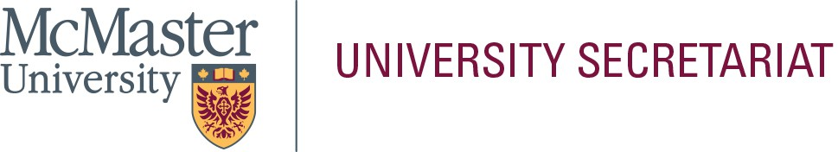

In the space below, please provide a statement (approximately 300-words) that will be helpful to the electorate in their selection. This page will be posted to the University Secretariat website exactly as submitted by the nominee; do not submit personal information on this page (i.e., address, telephone number, e-mail address, photograph, etc.). Please limit your statement to this page only.

**Name of Nominee: _**Gillian R. Goward

Professor Gillian Goward is a faculty member in the Department of Chemistry and Chemical Biology (CCB) at McMaster University in Canada. She completed her undergraduate degree in Chemistry at McMaster University in 1995, and her PhD at the University of Waterloo in 1999. She received an NSERC post-doctoral fellowship which she held at the Max Planck Institute for Polymer Research in Mainz, Germany. In 2002 she began her independent career at McMaster University.

Prof. Goward has mentored over 50 undergraduate students and supervised 7 MSc.,17 Ph.D. students and 8 PDFs. Together her research team has published more than 140 manuscripts in peer-reviewed journals. She has secured over $10M in funding throughout her academic career, including a NSERC Mission Alliance grant in the 2024 Critical Minerals competition, bringing together researchers in Engineering and Science, to collaborate with Li-Cycle, a Canadian start-up company focusing on lithium battery recycling. Previously, she was awarded an Automotive Partnerships Canada Grant collaborative grant of $3.5M, on which she was the principal investigator. She was a recipient of a 2020 Faculty of Science Research Chair in Magnetic Resonance Studies of Energy Materials. Her particular focus is on characterizing the structure and dynamics in Li-ion batteries through magnetic resonance spectroscopy and imaging. With this focus, she has also served as academic director of the NMR facility from

2017-2024, which is one of the flagship core research platforms at McMaster. She also served as a senior editor for the American Chemical Society publication, the American Chemical Society's Journal of Physical Chemistry from 2017-2024.

In 2019 she led the creation of a new undergraduate program in Sustainable Chemistry at McMaster together with colleagues in CCB. Prof. Goward has held leadership roles at McMaster including acting Associate Dean Research & External Relation (2016-2017) and Chair of Chemistry & Chemical Biology (2017-2022; 2023-2024). Most recently, she was appointed as Associate Dean Research & External Relation in the Faculty of Science, from July

2024-present. In the spring of 2024, she was one of the recipients of the MUFA Award for Outstanding Service.