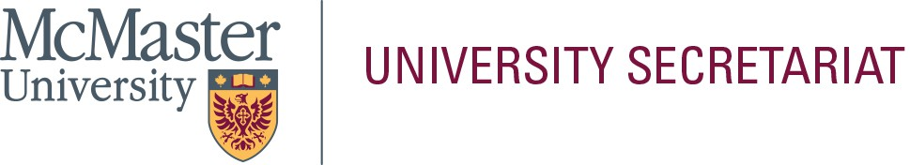

In the space below, please provide a statement (approximately 300-words) that will be helpful to the electorate in their selection. This page will be posted to the University Secretariat website exactly as submitted by the nominee; do not submit personal information on this page (i.e., address, telephone number, e-mail address, photograph, etc.). Please limit your statement to this page only.

**Name of Nominee: _**Yang Pan

I received my Ph.D. from the University of Iowa. My research focuses on digital marketing (influencer marketing, word of mouth), marketing-finance interface (pricing power, customer satisfaction) and retail analytics (basket analysis and choice modeling on big data). I have published at European Journal of Marketing (ABDC A*), Journal of Marketing Management (ABDC A) and marketing science institute working paper series, I also have papers under advanced round of r&r at Journal of Retailing (ABDC A*, DSB 45, ABS 4), International Journal of Electronic Commerce (ABDC A, DSB 45), and International Journal of Marketing Research (ABDC A*, DSB 45, ABS 4), I have presented my projects at Marketing Science conferences and American Marketing Association conferences. I served as ad hoc reviewers for Journal of Academy of Marketing Science and European Journal of Marketing.

# EDUCATION BACKGROUND

2019 Ph.D. in Business Administration – Marketing, University of Iowa; Tippie College of Business; Iowa City, Iowa, USA; 2019.

2013 MSc in Applied Economics – Finance, University of Science and Technology of China; the School of Management; Hefei, Anhui, China; 2013

2011 BSc in Statistics, University of Science and Technology of China; the School of the Gifted Young; Hefei, Anhui, China; 2011

# CURRENT STATUS

2019 - Present Assistant Professor (tenure-track), DeGroote School of Business, McMaster University

# SUPERVISORSHIPS

* Supervisory Committees: Rehan Khan
* Supervisory Committees: Shayan Abbasi

# LIFETIME RESEARCH FUNDING

* 2020- 2021: Yang Pan, Explore Research and Research Creation Grant, Arts Research Board, $3686.
* 2019-2025: Yang Pan, Research Start-Up Grant, McMaster University, $50000,
* 2020-2025: Yang Pan, Ruhai Wu, Gary Russell, “Multi-category analysis: Reconciling Habitual and Situational Shopping Behaviors”, Insight Grant, Social Sciences and Humanities Research Council, $71544
* 2020-2023: Yang Pan, Gary Russell, “A Multivariate Spatial Model to Predict Demand for a New Store without Historical Data”, Insight Development Grant, Social Sciences and Humanities Research Council, $34356

# COURSES TAUGHT

1. Undergraduate: Marketing Research, (median rating 10/10 on three sections out of four in 2024)
2. Graduate: Marketing Research