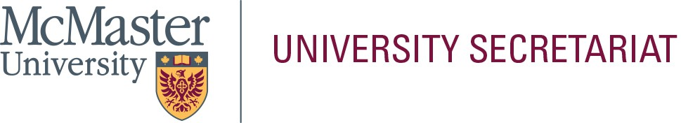

In the space below, please provide a statement (approximately 300-words) that will be helpful to the electorate in their selection. This page will be posted to the University Secretariat website exactly as submitted by the nominee; do not submit personal information on this page (i.e., address, telephone number, e-mail address, photograph, etc.). Please limit your statement to this page only.

**Name of Nominee: _**Emad Mohammad

As a tenured faculty member at the DSB, I value the advancement of the DSB through research, teaching, and community engagement. I joined the DSB in 2004, and I have served in many administrative positions and standing committees. Also, I have served on many ad hoc committees and selection and recruiting committees at the Area, Faculty, and University levels.

I have experience that is relevant for the DSB’s T&P committee. First, I have been serving on the Accounting and Financial Management Services (AFMS) Area’s T&P Committee since my tenure in 2010. Second, I served on the DSB’s Tenure and Promotion Committee from 2012 to 2015. Third, I served on many selection committees for the hiring of senior administrators at the DSB and the University levels. Fourth, I served on many selection committees for the appointment of research chairs. Finally, I still serve on the AFMS Area’s hiring committee. Although the purposes of these committees are different, the common thread among these roles is the ability to assess the candidates’ suitability for the position (or T&P) or to be successful in their roles as either administrators, research chairs, or tenured faculty members.