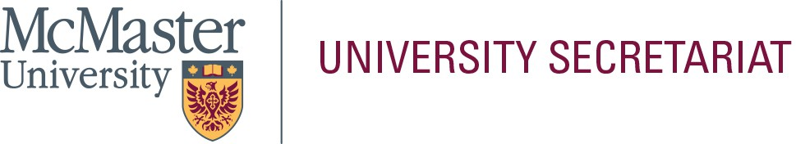

In the space below, please provide a statement (approximately 300-words) that will be helpful to the electorate in their selection. This page will be posted to the University Secretariat website exactly as submitted by the nominee; do not submit personal information on this page (i.e., address, telephone number, e-mail address, photograph, etc.). Please limit your statement to this page only.

**Name of Nominee: _**Peter Miu

Education Background:

Ph.D., Finance, University of Toronto M.B.A., Finance, University of Toronto

B.Sc. (Hon.), Civil Engineering, University of Hong Kong

Current Status at McMaster: Professor of Finance

Scholarly Activities:

Dr. Miu’s research is primarily in the areas of credit risk modeling, financial institutions, exchange-traded funds, regulatory capital requirement, and investments. His research appears in journals such as the Journal of Financial Intermediation, Journal of Banking & Finance, Journal of Empirical Finance, and the Journal of Credit Risk.

Administrative Responsibilities (last five years):

Member, Faculty of Business Tenure and Promotion Committee (since July 2023) Member, Graduate Council (since July 2024)

Member, Undergraduate Council (2020-2022)

Chair, Awards Committee, Undergraduate Council (2021-2022) Member, University Senate (2018-2021)

Member, Senate Committee on Appointments (2019-2021) Chair, Senate By-Laws Committee (2019-2021)