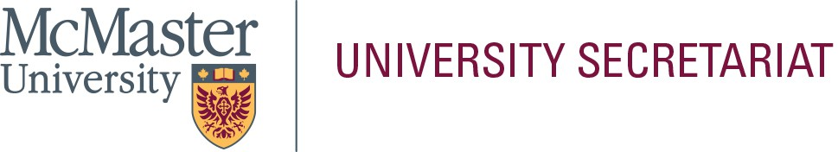

In the space below, please provide a statement (approximately 300-words) that will be helpful to the electorate in their selection. This page will be posted to the University Secretariat website exactly as submitted by the nominee; do not submit personal information on this page (i.e., address, telephone number, e-mail address, photograph, etc.). Please limit your statement to this page only.

**Name of Nominee: _**Alfred Liu

I am honored to be considered for a position on the Dean’s Advisory Council at the DeGroote School of Business. I am motivated to bring my expertise in research, teaching, and service to help shape the school’s strategic direction and advance its mission of excellence and commitment to education with a purpose.

I am currently an Associate Professor at McMaster University. My research focuses on emerging and cross-disciplinary areas at the intersection of accounting, finance, sustainability, business ethics, and innovation. My work explores how technological advancements and other issues impact corporate transparency, risk management, and governance, and has published extensively in top-tier and high quality journals. These areas are not only critical to academia but also align with the broader trends reshaping business practices and the financial markets today. In addition to my research, I am deeply committed to fostering a vibrant and inclusive academic environment, especially a supportive learning environment for my students.

At McMaster, I have served on several committees involved in student affairs and curriculum assessment, contributing to the development of policies that attract and support diverse, high-achieving students. At my previous institutions, I chaired research and teaching committees, which equipped me with valuable experience in driving initiatives that enhance both faculty and student success. I was also a senator in university committees overseeing the transition of various programs to embrace AI and data analytics.

I view the Dean’s Advisory Council as a pivotal forum for addressing key challenges and identifying opportunities for growth within our school. I look forward to the opportunities to contribute meaningfully to discussions about innovation, curriculum development, and institutional priorities.